EXPERIMENT NO:29

Design DFA using simulator to accept the input string “bc” ,”c”,and ”bcaaa”.

AIM:

Design DFA using simulator to accept the input string “bc” ,”c”,and ”bcaaa”.

INPUT:

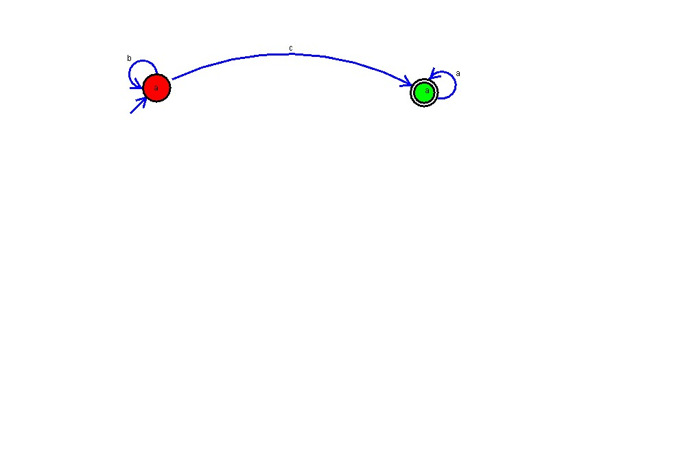

OUTPUT:

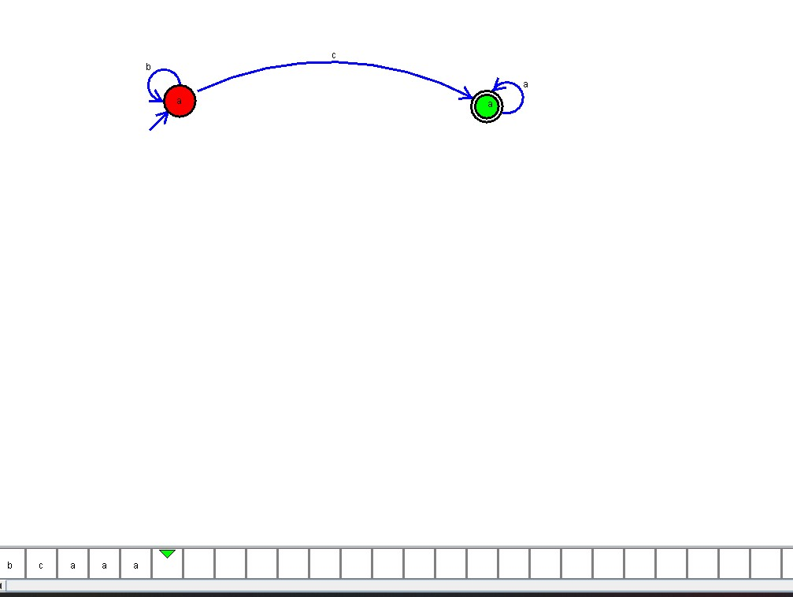

RESULT:

THUS THE PROGRAM WAS EXECUTED SUCCESSFULLLY.